Application under Rules 1.1 and 1.2 and Articles 143(1) and 143(2A) of the Credit Risk: Internal Ratings Based Approach (CRR) Part for permission to use the IRB approach (IRB application)

This pack should be used by institutions applying under Rules 1.1 and 1.2 and Articles 143(1) and 143(2A) of the Credit Risk: Internal Ratings Based Approach (CRR) Part of the PRA Rulebook for permission to use the Internal Ratings Based (IRB) approach to calculate risk-weighted exposure amounts for credit risk.

The application process is modular and there are eight separate forms that need to be completed for each module of the application process. Please see the ‘Notes for Completion’ section for details of how and when to submit each module. Applicants will initially need to submit a completed application form for Module 1 with responses to requests for information contained in the module (the PRA may request further information, including additional documentation, at a later stage). Please include the following with the completed Module 1 application form:
- The declarations and signatures form, signed by your firm’s chief executive officer (CEO) or equivalent (as agreed with the PRA supervision team).
- The fee for the application or proof of payment.
Completed forms should be marked for the attention of the PRA Authorisations - Assessment and Monitoring Team.
All information must be submitted in electronic format by email to
CRRModelPermissions@bankofengland.co.uk with the exception of the declaration form where a hard copy must be forwarded to the address below.
PRA Authorisations - Assessment and Monitoring Team
Prudential Regulation Authority
20 Moorgate
London
EC2R 6DA
NOTE: Submitting a signed application confirms the applicant's consent for any information provided to be shared with other UK regulators for the purposes of the approvals process.

Contents
Module 1 – Scoping
Module 2 – Technical model reviews
Module 3 – IT and data
Module 4 – Use test and experience test
Module 5 – Permanent partial use and roll-out plans
Module 6 – Financial reporting and stress testing
Module 7 – Internal audit and independent validation
Module 8 – Governance
Declaration form
Notes for completion

This pack sets out the information to be submitted by a firm making an initial IRB application under
Rules 1.1 and 1.2 and Articles 143(1) and 143(2A) of the Credit Risk: Internal Ratings Based Approach (CRR) Part.
The PRA’s review process is designed to:
- assess compliance with PRA Rules and any relevant supervisory statements;
- assess prudential risk; and
- ensure a consistent treatment for all firms.
The IRB application process is split into three phases made up of eight modules. Each module covers a different aspect of a firm’s plans for IRB implementation and applicants are required to provide a response to all of the questions in each module. Each module submitted to the PRA must be signed off by the firm's CEO or other appropriate senior manager as agreed with your supervisory team.
The process is summarised in the diagram below.

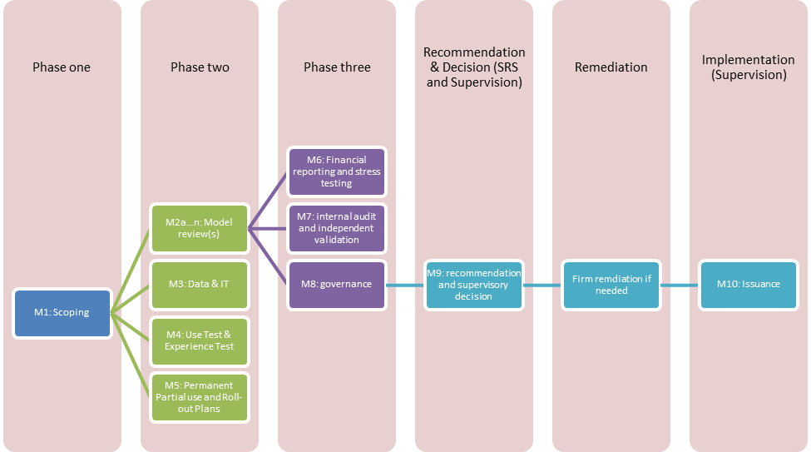

A separate form must be completed for each phase and submitted in the following order:
- Phase one - Module 1
- Phase two - Modules 2-5
- Phase three - Modules 6-8
The PRA will offer non-binding feedback at completion of each phase. However, firms should not assume that positive feedback guarantees approval, that non-communication implies there are no issues, or that remediation will not be required. The final decision is taken at completion of the full review, through a formal governance framework. This ensures:
- the PRA holds all firms to the same standards;
- the PRA can holistically consider the materiality of issues found against the quality of application in other areas; and
- input is taken from specialists at the PRA and wider Bank, and other stakeholders as required.
The PRA may offer the firm an opportunity to remediate prior to final decision where appropriate.
The information required in module 1 will inform the scope of supervisory review work with regard to assessing a firm's IRB application. Specifically, it should enable the PRA to:

- understand the work the firm has undertaken and assess whether the firm has a credible strategy meeting the PRA’s requirements; and
- identify, from an IRB perspective, the key areas of risk for the PRA to focus resource.
In response to all modules, the PRA expects that where a firm submits an application for a permission relating to the IRB approach, or notifies the PRA of an extension or change to an IRB rating system, it should provide the PRA with a self-assessment of whether it complies with all relevant CRR articles, PRA rules and SS expectations. The PRA expects applicants to clearly highlight any material gaps against any relevant CRR articles, PRA rules and SS expectations, to specify who is responsible for addressing such material gaps and the levels of governance involved, and to provide a credible and timely plan for remedying them in advance of approval where appropriate.

The information contained in the application should be as complete and accurate as possible. This is because the PRA will rely on the information to determine whether or not to grant an IRB permission. Firms are reminded that under Fundamental Rule 7, they must deal with regulators in an open and cooperative way and must appropriately disclose anything the PRA would reasonably expect notice of.
As part of its assessment of each module, the PRA will request and analyse further detailed information on particular topics, business lines, rating systems or models. The PRA expects that most of this information will already be contained in internal documents and so can be delivered quickly.
The PRA will undertake visits as part of its follow-up work and has indicated where these are always required (‘will require’) and where visits may be undertaken on a risk-based judgement or firm-specific basis (‘may require’).
Firms with international activities should be aware that the PRA will share the information contained within the application pack with other regulators (including both UK and non-UK regulators) as needed to support the approval process.

Phase One
The PRA will review IRB applications in phases. There is no need to submit information for later phases until the completion of preceding phases. However, when necessary, the PRA may request specific additional documents or information. At the completion of phase one (scoping), the PRA will agree indicative timescales with the applicant for subsequent phases and enable planning of key meetings.

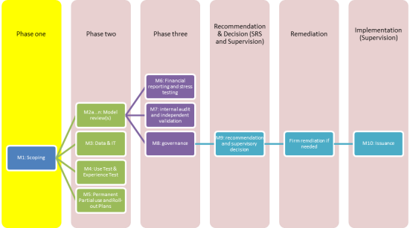
Module 1 – Scoping
This section requires a high-level overview of the firm's proposed IRB approach and implementation plans. The PRA will use the information requested here to define the scope of the detailed review, and the PRA will request further information on these topics in later modules.
In order to support the scoping process, the PRA will arrange to meet with the relevant teams involved in the IRB application, these are likely to include the following:
Attendees | To discuss
Chair of the designated committee | - Reasons for applying for an IRB permission  - Governance of IRB  - Models overview  - Use test and experience test  - Roll-out and permanent partial use  - Project Plan of IRB application review (PRA)
Head of the model development team | - Overview of each rating system
Senior business manager | - Overview of commercial plans for modelled portfolios
Senior manager from Credit Risk Management | - Overview of credit risks for modelled portfolios
Head of independent model validation team | - Overview of validation process

The PRA will expect firms to provide a presentation at each meeting giving an overview of the topics for discussion. Firms should submit these presentations as part of the application or as agreed with the firm’s supervision team. The PRA welcomes discussion of potential dates for this meeting prior to submission of the application but will be unable to start the review or hold the meetings until receipt of the completed application and accompanying fee.

Please submit the following information for module 1:

General
1.1 Purpose: a summary of why the firm is applying for an IRB permission and what it aims to achieve as a consequence.
1.2 Use: an indication of whether the application is for individual, sub-consolidated or consolidated use.
1.3 A list of all regulated entities making the application, and all members of the relevant consolidation and sub-consolidation groups if the application is on a consolidated or sub-consolidated basis. If the application is on an individual basis, indicate whether the applicant has an active Article 9 (CRR) (individual consolidation) permission and list the entities included in that permission.
1.4 If the group application includes exposures arising in non-UK subsidiaries, provide the total exposures by each non-UK subsidiary and Rating System.
1.5 If non-UK regulators might reasonably be expected to have an interest in the IRB application (for instance, if part of the group or a subsidiary is based in a non-UK country), provide a list of all relevant non-UK regulators, listed by Rating System.
1.6 A high-level model inventory listing which exposures, legal entities and geographical locations are covered by which rating systems, including any that will be excluded (eg through permanent partial use).
1.7 A complete list of all other IRB-related permissions being sought as part of the IRB application. Relevant permissions include:
- Permission to use the overseas model approach (Article 143(6) of the Credit Risk: Internal Ratings Based Approach (CRR) Part);
- Permission to implement the IRB approach sequentially (Article 148(1) of the Credit Risk: Internal Ratings Based Approach (CRR) Part);
- Permission to implement the advanced IRB approach sequentially in the non-retail AIRB modelling roll-out category (Article 148(1A) of the Credit Risk: Internal Ratings Based Approach (CRR) Part;
- Permission to permanently apply the standardised approach (Article 150(1) of the Credit Risk: Internal Ratings Based Approach (CRR) Part);
- Permission to permanently apply the foundation IRB approach (Article 150(4) of the Credit Risk: Internal Ratings Based Approach (CRR) Part);
- Permission to disapply IRB requirements to achieve broad equivalence with the definition of default in historic data (Article 179(1A) Of the Credit Risk: Internal ratings Based Approach (CRR) Part);
- Permission to treat additional physical collateral as eligible under the foundation collateral method (Article 199(6) of the Credit Risk: Credit Risk Mitigation (CRR) Part);
1.8 A financial assessment of the impact of IRB approval, including on capital ratios.
1.9 A single point of contact for the IRB application.

Structure
Please submit a summary of the structure of your firm, including from a credit control, risk management and capital allocation perspective. The explanation of the structure of your firm should cover:
1.10 | A description of the group and legal entity structure.
1.11 | The organisation of business units and reporting lines.
1.12 | An overview of the management committee structure and relevant sub-committees
1.13 | A summary of the structure and role of internal audit.
1.14 | The role of external audit and/or other independent third parties.
1.15 | IRB reporting structures – how and with what frequency IRB specific management information is reported to risk management, internal audit and board functions with reference to Articles 185 and 189 to 191 of the Credit Risk: Internal Ratings Based Approach (CRR) Part, Article 430 of the Reporting (CRR) Part and any other relevant management information and committee reports.
1.16 | A brief summary of how the requirements set out in Article 189 of the Credit Risk: Internal Ratings Based Approach (CRR) Part (corporate governance) and Article 190 of the Credit Risk: Internal Ratings Based Approach (CRR) Part (credit risk control) are met.
1.17 | A summary of any significant changes to the structure that are planned for the future.
1.18 | An overview of the IT, data and reporting infrastructure and governance.
1.19 | An overview of the stress testing framework and supporting governance, infrastructure, and models
1.20 | Any key areas of compliance, business or prudential risk related to the application. While the PRA expects the application to be compliant when received, applicants are responsible for notifying the PRA of any changes to the information provided during the course of the application process

Self-assessment and attestation
This section requires an overview of the firm's own self-assessment. Self-assessment is a necessary and important part of the application because it provides evidence that the firm has considered and assessed compliance against relevant PRA rules and supervisory expectations and any relevant CRR requirements. The PRA will take into account the comprehensiveness and quality of the work undertaken as part of the self-assessment when scoping out its own supervisory review work.
The scope of self-assessment should include, but not necessarily be restricted to, a paragraph-by-paragraph assessment of compliance against all the relevant PRA rules, supervisory expectations and CRR requirements that are relevant to the application as set out in paragraph 2.14 of SS 4/24.
1.21 | Confirmation that self-assessment has taken place and been reviewed by the signatory.
1.22 | Description of the self-assessment process undertaken by the firm.
1.23 | Full self-assessment.
1.24 | As part of the self-assessment, any non-compliance identified. Outline the steps being taken to bring the firm into material compliance and when these steps are expected to be completed.

Declaration
This section should be signed by the firm's chief executive or equivalent and accompany the first module.

Warning
Knowingly or recklessly giving the PRA information which is false or misleading in a material particular may be a criminal offence (sections 398 and 400 of the Financial Services and Markets Act 2000). Chapter 6 of the Notifications Part of the PRA Rulebook requires an authorised person to take reasonable steps to ensure the accuracy and completeness of information given to the PRA and to notify the PRA immediately if materially inaccurate information has been provided. Contravention of these requirements may lead to disciplinary sanctions or other enforcement action by the PRA. It should not be assumed that information is known to the PRA merely because it is in the public domain or has previously been disclosed to the PRA or another regulatory body.

Data Protection
For the purposes of complying with the Data Protection Act, the personal information in this form will be used by the PRA to discharge its statutory functions under the Financial Services and Markets Act 2000 and other relevant legislation. It will not be disclosed for any other purposes without the permission of the applicant.

Declaration
This is an application under Rules 1.1 and 1.2 and Articles 143(1) and 143(2A) of the Credit Risk: Internal Ratings Based Approach (CRR) Part for permission to use the IRB approach, made by:-

Name of firm or group: (please insert here)
Click or tap here to enter text.

By submitting this application:
- I sign this application on behalf of all the legal entities making the application.
- I confirm that the information contained with this application represents a true and fair view to the best of my knowledge and belief and that I have taken all reasonable steps to ensure that this is the case.
- I confirm I am aware that it may be a criminal offence knowingly or recklessly to give the PRA information that is false or misleading in a material particular.
- I acknowledge that some questions do not require us to provide supporting evidence in response. However, the records which demonstrate the applicant firm's compliance with the proposed rules in relation to the questions will be available to the PRA on request.
- I acknowledge that I will notify the PRA immediately if there is a significant change to the information given in the form. If I fail to do so, this may result in a delay in the application process.
- I confirm that I give agreement for any information provided in relation to this application to be shared with other UK regulators at the PRA's discretion.

Date Click or tap here to enter text. _______________________________________________________

Name of signatory Click or tap here to enter text. _______________________________________________________

Position of signatory Click or tap here to enter text. ______________________________________________________

Individual Registration Number Click or tap here to enter text. _______________________________________________________

Signature Click or tap here to enter text. _______________________________________________________

Phase Two
Please do not complete these modules until advised by the firm’s supervisor.
Modules 2-5 comprise phase two of the application process and should be completed in parallel.

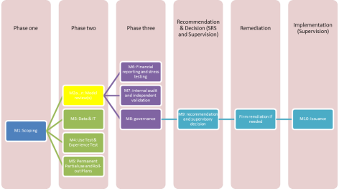
Module 2 – Technical model review
This module requires more detailed information on the rating systems and internal models that the firm is seeking permission to use for the IRB approach. This information will enable the PRA to build a picture of the key characteristics of the component parts of the firm's IRB approach and help focus supervisory review work on material rating systems, poorly performing rating systems and rating systems used in challenging areas.
This module will require meetings with the:
- model development team; and
- independent model validation team.
For each rating system please submit:
  - Full self-assessment.
  - Complete model development documentation (Article 175 of the Credit Risk: Internal Ratings Based Approach (CRR) Part), including that of underlying scorecards (eg application scorecards).
  - Independent Validation report.
  - Relevant Internal Audit (or equivalent) reports.
  - Model validation and monitoring reports if available. If the firm is not yet monitoring the rating system, please submit evidence of how the monitoring and validation requirements will be met going forward (Article 185 of the Credit Risk: Internal Ratings Based Approach (CRR) Part).
  - Minutes of committee discussion and decisions relating to the above (including non-approval decisions where appropriate).
  - Any other relevant information.

For mortgage rating systems, please submit a completed Rating system structured information request and a completed Probability of possession given default request for each rating system.

Applicants must also provide any relevant information where specific permissions (as listed in 1.7 above) are applied for, if these are relevant to the rating system.

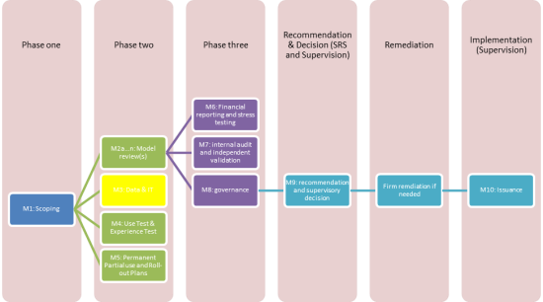
Module 3 – IT and data
This module requires more detailed information on your IT systems used for IRB model management and reporting, and your approach to data governance.
This module will require meetings with:
- Chairs of committees that review or approve data governance reports or policies.

Please submit the following information:
3.1 A summary of the firm's approach to data management.
3.2 A high-level map of data and reporting systems used for IRB model management and capital requirements reporting. State for each system whether the system is used for other (non-IRB) purposes currently.
3.3 A description of how the firm ensures that it meets IRB data requirements and expectations, including use of proxies, and testing of systems, quality control, and change control, an explanation of how the firm reconciles between finance and risk system a copy of that reconciliation and commentary on any differences.
3.4 Relevant Internal Audit or other independent review material relating to the IT and Data systems.
3.5 Copies of Data Quality, Data Governance standards or similar.
3.6 Copies of the latest management information (MI) and committee minutes related to Data Quality and Governance where appropriate.

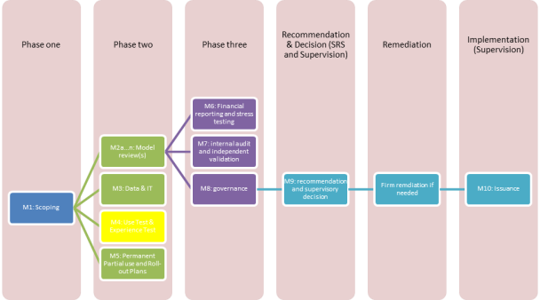
Module 4 – Use test and experience test
This module requires more detail on the firm’s compliance with the use test and experience test requirements for the IRB approach.
This module may require meetings with the:
- Chair of the designated committee; and
- Business or Credit Risk teams.
Please submit the following information:
4.1 A description of how the IRB approach currently forms an essential part of the firm's business and risk management processes and procedures. In particular, the use and integration of rating systems for each of the following areas:
- Credit approval
- Individual and portfolio limit setting
- Reporting of credit risk information
- Provisioning
- Other significant criteria used in decisions relating to credit risk or its assessment
- Economic capital
- Total regulatory credit risk capital requirements
- Risk appetite
- Strategy and acquisitions
- Profitability and performance
- Performance-related remuneration
- Carrying out your firm's obligations under the requirement for individual capital assessment
- Other activities the firm deems relevant.
  - A summary of any planned changes relevant to the firm’s compliance with the use test.
  - An outline of the differences, if any, between the parameters used for regulatory capital purposes and those used for internal purposes.
  - A brief description of the infrastructure put in place to support the IRB framework. The description should cover information technology, skills and resources, organisational culture, model development and other standard processes, internal acceptance of new systems and any other areas deemed relevant by your firm.
4.5 A detailed explanation of how the firm meets the prior experience requirement (Article 145 of the Credit Risk: Internal Ratings Based Approach (CRR) Part). Please include all relevant evidence including at least three years of monitoring, validation and audit of the firm’s IRB framework and evidence that a complete IRB governance framework has been through at least one annual cycle since approval.

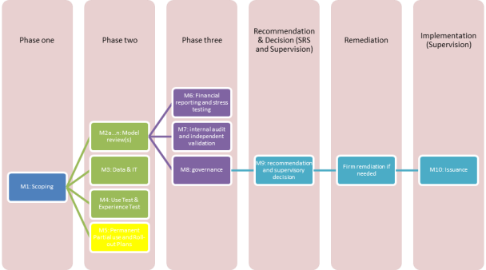
Module 5 – Permanent partial use and roll-out
Permanent Partial Use (PPU) of the Standardised Approach
Firms are required to submit details of the exposures for which they are requesting to apply PPU of the Standardised Approach. This information should be provided in line with each of the relevant criteria set out in Article 150(1) of the Credit Risk: Internal Ratings Based Approach (CRR) Part.
Permanent Partial Use of the FIRB Approach
Where firms are applying to use the FIRB approach for some non-retail exposures and the AIRB approach for other non-retail exposures, they should submit details of the exposures for which they are requesting to use the FIRB approach in line with the criteria set out in Article 150(4) of the Credit Risk: Internal Ratings Based Approach (CRR) Part.
Roll-out of the IRB Approach
Where firms are applying to roll out the IRB approach sequentially in accordance with Article 148(1) of the Credit Risk: Internal Ratings Based Approach (CRR) Part, they are required to submit details of the projected capital impact of the IRB implementation roll-out plan, including the timetable for the roll-out of IRB approaches in a GANTT chart or similar. Where relevant, firms should include model roll-out plans for overseas subsidiaries. Details of the projected capital impact of the roll-out plan should be broken down in accordance with Article 148(1) of the Credit Risk: Internal Ratings Based Approach (CRR) Part by (where relevant):
- Roll-out class (as laid out in Article 147B of the Credit Risk: Internal Ratings Based Approach (CRR) Part)
- Types of exposures within the same roll-out class
- For a given roll-out class, business units in the same group
Roll-out of the AIRB Approach to non-retail exposures
Where firms are applying to roll out the AIRB approach for non-retail exposures sequentially in accordance with Article 148(1A) of the Credit Risk: Internal Ratings Based Approach (CRR) Part, they are also required to submit details of the projected capital impact of the AIRB implementation roll-out plan for non-retail exposures by:
- Types of exposures
- For a given type of exposures, business units in the same group
The contents of this module should be clearly linked to the rating systems in Module 2.
It is not expected that this module will require meetings with the firm.
5.1 Please submit a completed Permanent partial use and roll-out plan self-assessment.
5.2 Where the firm is applying for permanent partial use of SA under Article 150(1) of the Credit Risk: Internal Ratings Based Approach (CRR) Part or sequential roll-out under Article 148(1) of the Credit Risk: Internal Ratings Based Approach (CRR) Part, please also submit a completed example reporting return OF 08.07 – Credit risk and free deliveries: IRB approach to capital requirements: scope of use of IRB and SA approaches. The example returns should be completed as if the permissions for which the firm has applied have been granted by the PRA.
5.3 Please submit any other relevant material.

Phase Three
Please do not complete this phase until advised by your supervisor.
Modules 6-8 comprise phase three of the application process and should be completed in parallel.

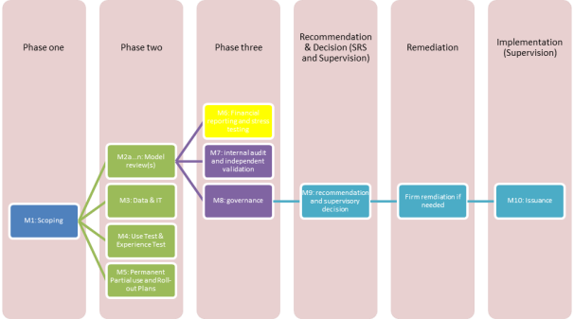
Module 6 – Financial reporting and stress testing
This module requires firms to provide details of the approach to credit risk stress testing and the financial reporting of IRB outputs.
This module may require meetings with:
- Chairs of committees that review or approve stress testing model projections
- Chairs of committees that will have responsibility for reviewing regular reporting model outputs
Please submit the following:
6.1 | A description of the firm’s approach to credit risk stress testing, in particular how the firm has met the requirements for stress testing set out in Article 177 of the Credit Risk: Internal Ratings Based Approach (CRR) Part; the frequency of reporting to senior management; and the design and impact of the economic cycle stress test.
6.2 | Copies of stress testing methodologies and models for IRB rating systems (including underlying impairment distributions), supporting documents and independent validation reports
6.3 | Copies of minutes of approval of the above methodologies and latest annual reviews of them
6.4 | Copies of the minutes or other relevant evidence of the governance of the final projections used for capital planning. If not available, please indicate when these will become available
6.5 | Other relevant material.
6.6 | A description of the governance of financial reporting of IRB outputs once approved, including key responsibilities and committees. If completed on an IRB basis, the latest ICAAP. Otherwise, projections under stress of:
 | 6.6.1 | IRB model outputs; and
 | 6.6.2 | Impairment forecasts for these portfolios

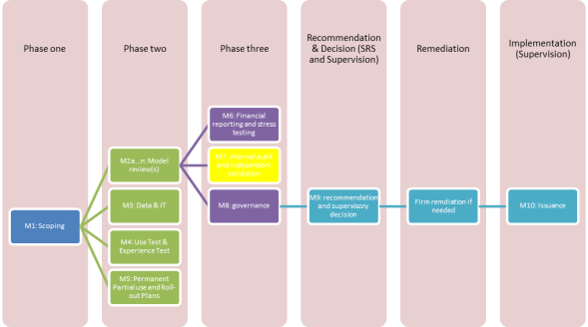
Module 7 – Internal Audit and Independent Validation functions
This module requires you to provide more details of your approach to independent validation of IRB models and the approach that Internal Audit will take to meeting the IRB requirements.
This module will typically require meetings with:
- Internal Audit;
- Independent Validation (if internal) or Senior Manager responsible for commissioning external independent validation reports; and
- Chair of the Board Audit Committee.

Please submit the following information.

Internal Audit
7.1 The role of the Audit Committee and of Internal Audit (Article 191 of the Credit Risk: Internal Ratings Based Approach (CRR) Part).
7.2 Latest copies of relevant Internal Audit reports.
7.3 Forward plan of Internal Audit work.

Validation
7.4 A summary of the firm's approach to independent validation. The summary should cover the following areas: reporting lines, accountability, independence, commissioning process, approval process, scope, model use, documentation, judgements made, continuing validation and monitoring. To the extent that the firm depends on external support for this function, a description of how that operates.
7.5 A brief description of the firm's general approach to IRB rating system performance monitoring (Article 185 of the Credit Risk: Internal Ratings Based Approach (CRR) Part). The summary should include how the assumptions, the discriminative power and the calibration of rating systems and/or models are monitored, particularly with regard to low default portfolios. Indicate the granularity and frequency of management information received by each committee.
7.6 A copy of the firm’s modelling and validation standards.
7.7 A description of what gives the firm's senior management comfort that the outputs from the rating systems and/or models are sufficiently robust.
7.8 A copy of validation reports for the last twelve months.

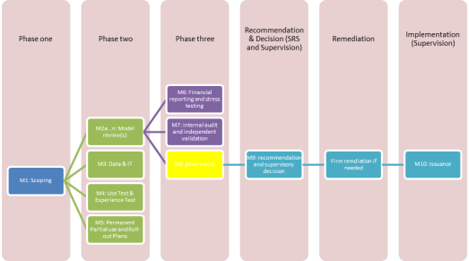
Module 8 – Governance
This section requires a summary of your firm's approach in a number of key areas, including governance, the use of internal ratings, data management and model validation.
This module will require meetings with:
- CEO, Chairman, Chair of Board Risk Committee.
- Chair of relevant committees that review model performance MI and annual model reviews.
- Chairs of Risk Committees.
- Relevant other Senior Managers.

Governance of credit risk – Independent oversight to support your approach for IRB
8.1 A summary of the firm's approach to governance of credit risk. The summary should include:
- The role of the board.
- How and where the board delegates activity, risk appetite, policies and authority to a sub-committee
- of the board or to senior management. Please include details of the composition of the designated
- committee and how it ensures independent oversight and how you have addressed any potential
- conflicts of interest.
- The role of senior management in governing credit risk more generally.
- The role and independence of the credit risk control unit, including how the requirements in Article 190 of the Credit Risk: Internal Ratings Based Approach (CRR) Part are met.
- The outsourcing of any relevant functions.
- How external models are controlled.
8.2 Set out the level of understanding and engagement expected of different levels of management (Article 189 of the Credit Risk: Internal Ratings Based Approach (CRR) Part) and how that is validated.
8.3 MI reports for evaluating performance of IRB rating systems. If not available yet, please supply the monitoring reports used to meet the experience and use test requirements (Article 185 of the Credit Risk: Internal Ratings Based Approach (CRR) Part).
8.4 Associated minutes with the above.

Model changes
8.5 Policies or processes by which material changes are to be identified that require prior permission from the PRA, as well as changes that require prior notification to the PRA in accordance with Articles 143(3) and 143(4)(b) and Articles 143A to 143D of the Credit risk: Internal Ratings Based Approach (CRR) Part.

